Project Title
Text Search and Intelligent Query Engine
Project Report submitted for the partial fulfilment of grade for the course

Data Structures and Algorithms -3 (25CS2103E)
in

A.Y. 2026-2027

Submitted by
Hamsika Peddina 2520030586
Vunnam VedaPriya 2520030376
Manne Thanishka 2520030583

Team Number: 23
Section: 5

Under the guidance of

Yamini Devi


<<Designation, Department>>
Hyderabad-500090, Telangana, India.

K L (Deemed to be) University
DEPARTMENT OF COMPUTER SCIENCE ENGINEERING / COMPUTER SCIENCE AND INFORMATION TECHNOLOGY/ARTIFICIAL INTELLIGENCE & DATA SCIENCE



DECLARATION

The Mini Project Report entitled “Project Title” is a record of Bonafide work of Hamsika Peddina –2520030586, Vunnam VedaPriya – 2520030376, Manne Thanishka – 2520030583 submitted in partial fulfillment for the award of B. Tech in Computer Science and Engineering/Computer Science and Information Technology/ Artifical Intelligence & data Science to the K L University. The results embodied in this report have not been copied from any other departments/University/Institute.

Hamsika Peddina – 2520030586
Manne Thanishka – 2520030583
Vunnam VedaPriya – 2520030376

K L (Deemed to be) University
DEPARTMENT OF COMPUTER SCIENCE ENGINEERING / COMPUTER SCIENCE AND INFORMATION TECHNOLOGY
CERTIFICATE

This is to certify that the mini project based report entitled “Text Search and Intelligent Query Engine” is a bonafide work done and submitted by Hamsika Peddina – 2520030586, V.VedaPriya– 2520030376, Manne Thanishka – 2520030583 in partial fulfillment of the requirements for the award of the degree of BACHELOR OF TECHNOLOGY in Department of Computer Science Engineering/ Computer Science and Information Technology/Artificial Intelligence & Data Science, K L (Deemed to be University), during the academic year 2026-2027.

Signature of the Supervisor

Signature of the HOD Signature of the External Examiner

ACKNOWLEDGEMENT

The success in this project would not have been possible but for the timely help and guidance rendered by many people. Our wish to express my sincere thanks to all those who has assisted us in one way or the other for the completion of my project.

Our greatest appreciation to my guide, <<Guide Name>>, <<Designation>>, <Department>> which cannot be expressed in words for his/her tremendous support, encouragement and guidance for this project.

We express our gratitude to Dr. P.Venkateshwar Rao (CSE)/Dr. Khaja Shareef (CSIT)/ Dr. Sreenath Itikela (AI&DS), Head of the Department for Computer Science Engineering/ Department for Computer Science and Information Technology/Department of Artificial Intelligence and Data Science for providing us with adequate facilities, ways and means by which we are able to complete this project-based Lab.

We thank all the members of teaching and non-teaching staff members, and also who have assisted me directly or indirectly for successful completion of this project. Finally, I sincerely thank my parents, friends and classmates for their kind help and cooperation during my work.

Hamsika Peddina – 2520030586
Manne Thanishka – 2520030583
Vunnam Veda Priya – 2520030376

TABLE OF CONTENTS

S.No. | Contents | Page no.
1. | Abstract
2. | Introduction
3. | Literature survey
4. | Problem Statement and Objectives
5. | Hardware and Software requirements
6. | Implementation
7. | Results & Discussion
8. | Conclusion & Future Scope
9. | References

1.ABSTRACT

Text Search and Analysis System is a Java-based application developed to demonstrate the use of advanced data structures and algorithms for efficient text searching and analysis. The system allows users to select either a predefined large dataset or their own text dataset and perform different text-processing operations.
The project implements five important algorithms and techniques: Knuth-Morris-Pratt (KMP) for searching a particular word or pattern, Edit Distance for finding the closest spelling match, Aho-Corasick for searching multiple keywords simultaneously, Suffix Array for text indexing, and LCP (Longest Common Prefix) Array for analyzing common prefixes between suffixes.
The predefined dataset included with the project contains approximately 4.46 MB of text and more than 554,000 words, providing a relatively large input for testing the algorithms. KMP, Edit Distance, and Aho-Corasick operate on the complete selected dataset, while Suffix Array and LCP Array analyze the first 6000 characters to maintain practical memory and execution requirements for a classroom Java project.
The system provides a menu-driven interface through which users can select datasets and operations. The project demonstrates how different algorithms can solve different text-search problems while emphasizing efficient data processing and algorithmic design.

Team Name:Text Search and Intelligent Query Engine
Team Members:
- [Hamsika Peddina, 2520030586]
- [Vunnam Veda Priya, 2520030376]
- [Manne Thanishka, 2520030583]

- INTRODUCTION

Text searching is an important operation in many computer applications such as search engines, document management systems, databases, information retrieval systems, and text-processing applications. When the amount of text becomes large, simple searching techniques may require significant processing time. Data structures and algorithms provide efficient approaches for searching, indexing, and analyzing textual information.
The Text Search and Analysis System is developed as a Java-based application to demonstrate how different algorithms can be applied to different text-processing requirements. The system provides an option to load a predefined large dataset or allow the user to provide their own .txt dataset.
The application contains five major algorithmic operations. KMP is used to find occurrences of a particular word or pattern. Edit Distance compares an entered word with words in the dataset and identifies the closest spelling match. Aho-Corasick allows multiple keywords to be searched simultaneously in a single pass through the text. Suffix Array creates an index of suffixes of the text, while the LCP Array determines the common-prefix lengths between adjacent suffixes.
The project therefore provides a practical demonstration of pattern matching, dynamic programming, multi-pattern searching, text indexing, and prefix analysis. It also allows the same dataset to be reused across different algorithms, making it easier to observe how different algorithmic techniques solve different problems.

- LITERATURE SURVEY
3.1 Knuth-Morris-Pratt Algorithm
The Knuth-Morris-Pratt algorithm is a pattern-matching algorithm used to search for a particular pattern within a larger text. It preprocesses the pattern and constructs an LPS (Longest Prefix Suffix) array. The LPS array allows the algorithm to avoid repeating unnecessary character comparisons after a mismatch. The KMP algorithm is implemented in this project for finding all occurrences of a user-entered word or pattern in the selected dataset.
3.2 Aho-Corasick Algorithm
The Aho-Corasick algorithm is designed for searching multiple patterns simultaneously within a text. It uses a trie structure to store the patterns and failure links to efficiently continue searching when a mismatch occurs. This approach allows multiple keywords to be processed during a single traversal of the text. In this project, Aho-Corasick is used to count the occurrences of multiple user-provided keywords in the selected dataset.
3.3 Edit Distance
Edit Distance is a string comparison technique commonly implemented using dynamic programming. It determines the minimum number of operations required to transform one string into another. The operations generally include insertion, deletion, and substitution of characters. In this project, Edit Distance is used for spelling comparison by comparing the user-entered word with unique words obtained from the dataset and identifying the closest word.
3.4 Suffix Array
A Suffix Array is an indexing data structure that stores the starting positions of all suffixes of a string in sorted order. It is useful for text indexing and string-processing applications because the sorted suffixes provide an organized representation of the text. In this project, a Suffix Array is constructed from up to the first 6000 characters of the selected dataset, and the first 20 suffix indexes are displayed as the result.
3.5 LCP Array
The Longest Common Prefix (LCP) Array is associated with a Suffix Array and stores the length of the longest common prefix between adjacent suffixes in sorted order. LCP information can be used to analyze similarities and repeated patterns within text. In this project, the LCP Array is generated using the suffixes represented by the Suffix Array, and the first 20 LCP values are displayed.
3.6 String Searching Applications
String-searching algorithms are widely used in applications that require finding specific information within large amounts of text. Different algorithms are suitable for different requirements, such as searching for one pattern, searching for several patterns, or performing approximate matching. The proposed system combines multiple searching techniques to demonstrate their different applications.
3.7 Dynamic Programming in Text Processing
Dynamic programming is an important algorithmic technique used to solve problems by dividing them into overlapping subproblems and storing previously calculated results. Edit Distance is a common application of dynamic programming in string processing. The project demonstrates this technique by calculating the minimum edit operations required between two words.
3.8 Text Indexing
Text indexing techniques are used to organize textual information so that it can be searched and analyzed efficiently. Suffix Arrays provide an example of an indexing structure that organizes suffixes according to their lexicographical order. The project implements a basic Suffix Array to demonstrate how indexing can be applied to text data.
3.9 Multi-Pattern Matching
Searching for several keywords separately can result in repeated processing of the same text. Multi-pattern matching algorithms address this problem by allowing multiple patterns to be searched together. Aho-Corasick provides such an approach using a trie and failure links and is therefore included in the project as a multiple-keyword searching technique.
3.10 Java-Based Algorithm Implementation
Java provides classes and data structures such as arrays, ArrayList, HashMap, HashSet, Queue, StringTokenizer, and file-handling classes that can be used to implement text-processing algorithms. The project uses Java to integrate the different algorithms into a menu-driven application and process both predefined and user-selected text datasets.

- Problem Statement and Objectives

Problem Statement:
To develop a Java-based text search and analysis system that applies suitable data structures and algorithms for searching, matching, indexing, and analyzing textual data.
Problem Description:
Searching and analyzing large text datasets involves different types of operations such as exact pattern matching, spelling comparison, multiple-keyword searching, and text indexing. A single algorithm cannot efficiently address all these requirements, so suitable algorithms must be implemented according to the type of operation.
Objectives:
- To develop a menu-driven Java application for text searching and analysis.
- To allow users to select a predefined dataset or provide their own .txt dataset.
- To implement the Knuth-Morris-Pratt algorithm for single-pattern searching.
- To implement Edit Distance for spelling comparison and approximate word matching.
- To implement the Aho-Corasick algorithm for searching multiple keywords.
- To implement a Suffix Array for text indexing.
- To implement an LCP Array for common-prefix analysis.
- To reuse the selected dataset across the different text-processing operations.
- To demonstrate the practical application of data structures and algorithms to text-processing problems.
- To provide a simple and user-friendly menu-driven interface for performing the implemented operations.

- HARDWARE AND SOFTWARE REQUIREMENTS

Hardware Requirements:
• Computer or laptop
• Minimum 4 GB RAM
• Intel Core i3 processor or equivalent
• Minimum 500 MB available storage
• Keyboard and monitor

Software Requirements:
• Operating System: Windows, Linux, or macOS
• Programming Language: Java
• Java Development Kit (JDK)
• Java Compiler: javac
• IDE/Text Editor: VS Code, IntelliJ IDEA, Eclipse, or equivalent
• Command Prompt/Terminal
• Plain text dataset (.txt)

- IMPLEMENTATION

The project is implemented using Java and consists of multiple modules, with each module responsible for a specific text-processing operation. The main program first loads the selected dataset and then allows the user to select the required operation.

6.1 Dataset Management Module
The DataSet module is responsible for reading and managing the selected text dataset. The system can load the predefined dataset or read a user-provided .txt file using its file path.
The dataset is read using Java file-handling classes and stored as a String. The text is converted to lowercase so that the searching operations can be performed without differences caused by uppercase and lowercase characters. The module also provides information about the selected dataset, including its source, file size, number of characters, and number of words.
The main methods provided by the DataSet class include getText(), getWordCount(), getWords(), and showInfo().
Code file: DataSet.java
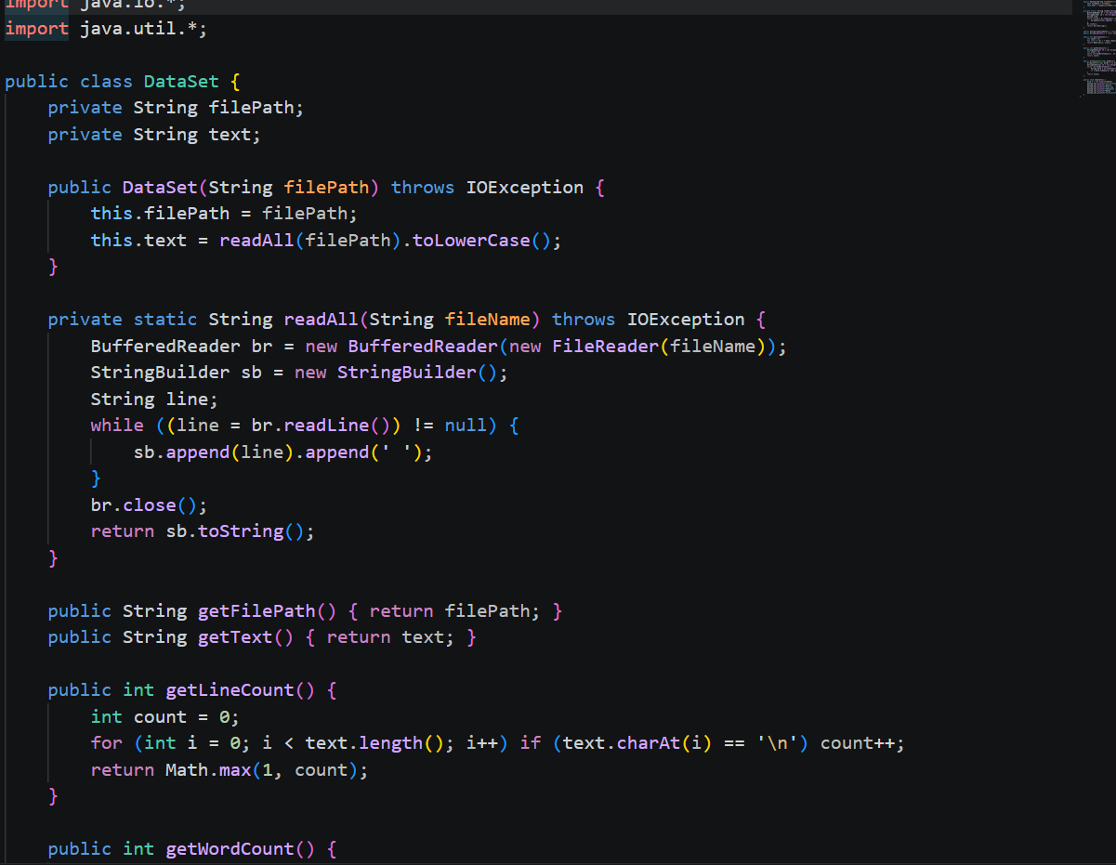
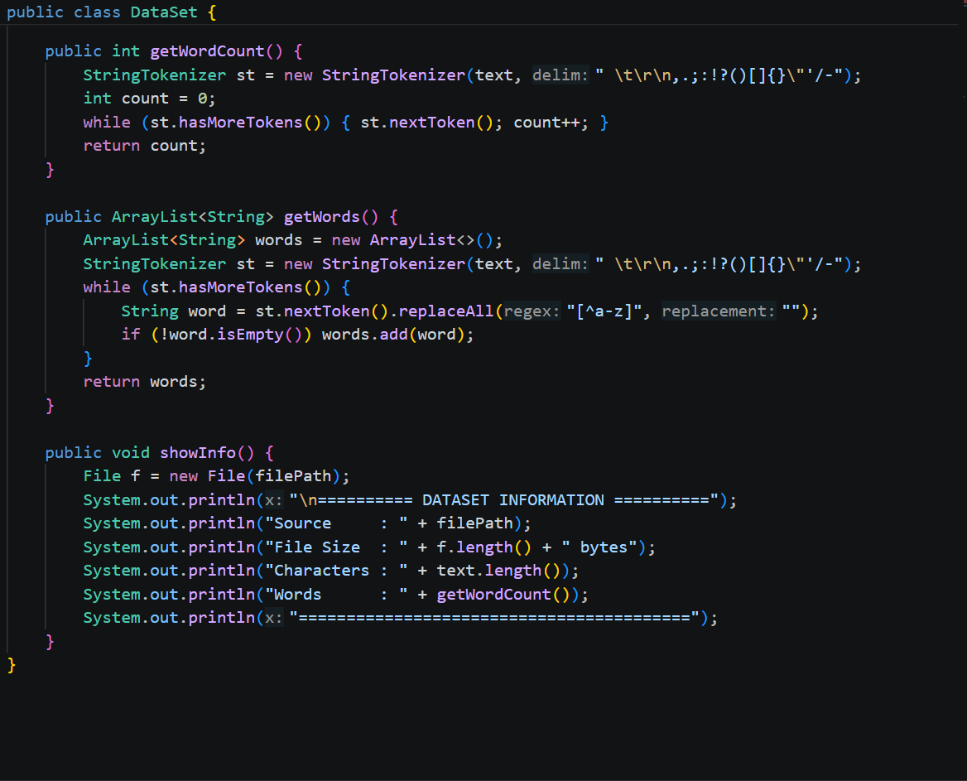
6.2 Main Menu and Dataset Selection Module
The Main class provides the main menu and controls the flow of the application. At the beginning, the user is asked to select the dataset source. The user can choose the predefined large dataset, provide the path of their own .txt dataset, or exit the application.
After loading the dataset, the program displays the available operations. The user can select KMP, Edit Distance, Aho-Corasick, Suffix Array, LCP Array, dataset information, or another dataset.
The Main class connects the user interface with the individual algorithm modules.
Code file: Main.java
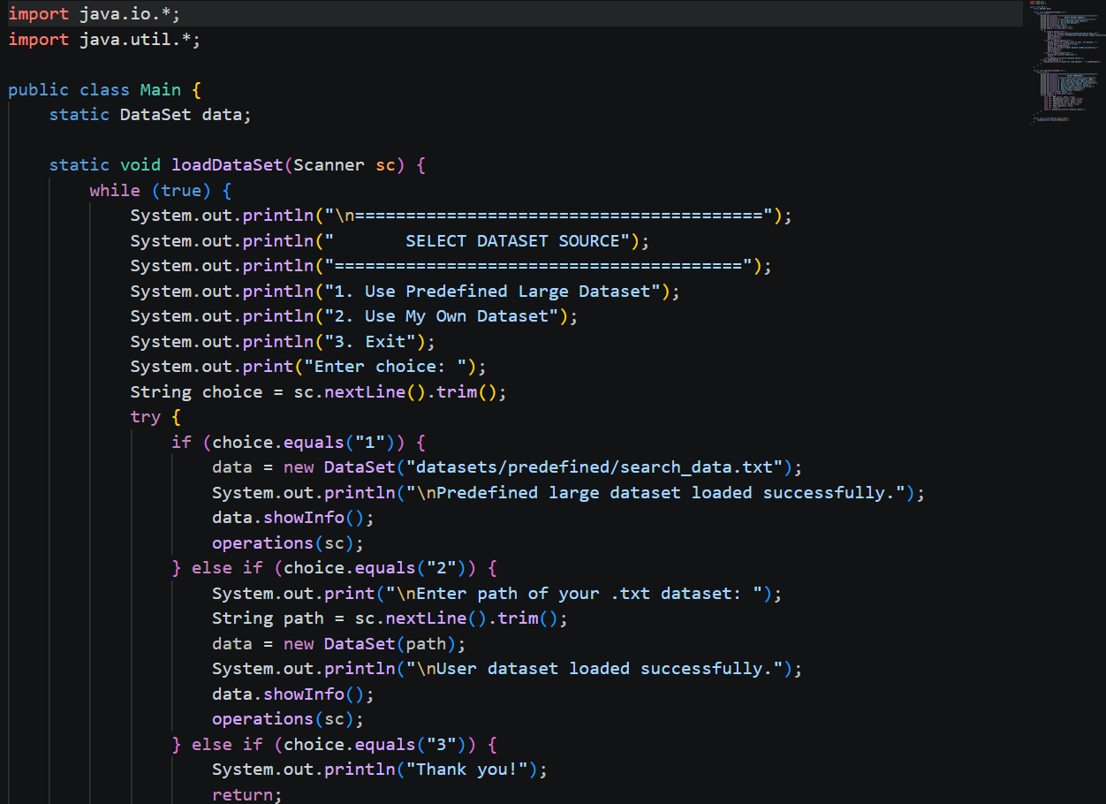
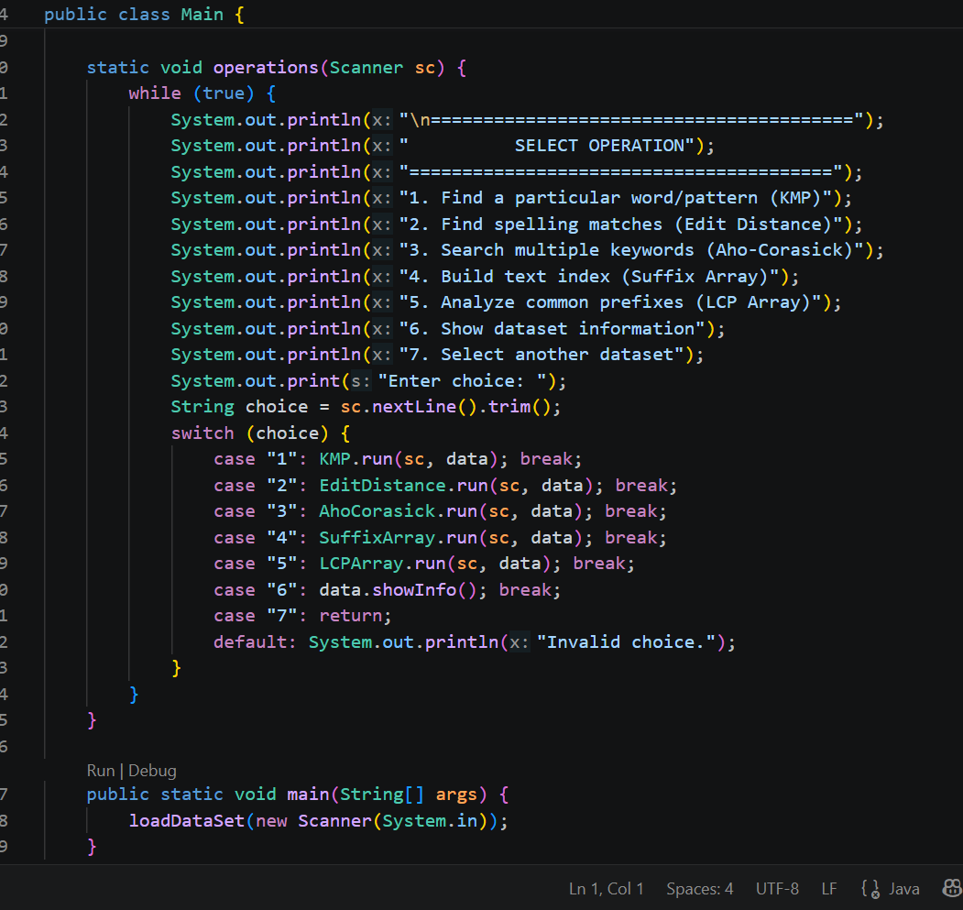

6.3 KMP Pattern Searching Module
The Knuth-Morris-Pratt algorithm is implemented in the KMP.java class. The algorithm first creates an LPS array for the input pattern. The LPS array stores information about the longest proper prefix that is also a suffix for each position in the pattern.
During the searching process, the algorithm compares the pattern with the selected text. When a mismatch occurs, the LPS array is used to determine the next position in the pattern instead of restarting the comparison from the beginning.
The program displays the entered pattern, total number of occurrences, and the first 20 matching positions. If the pattern is not found, the system displays an appropriate message.
Code file: KMP.java
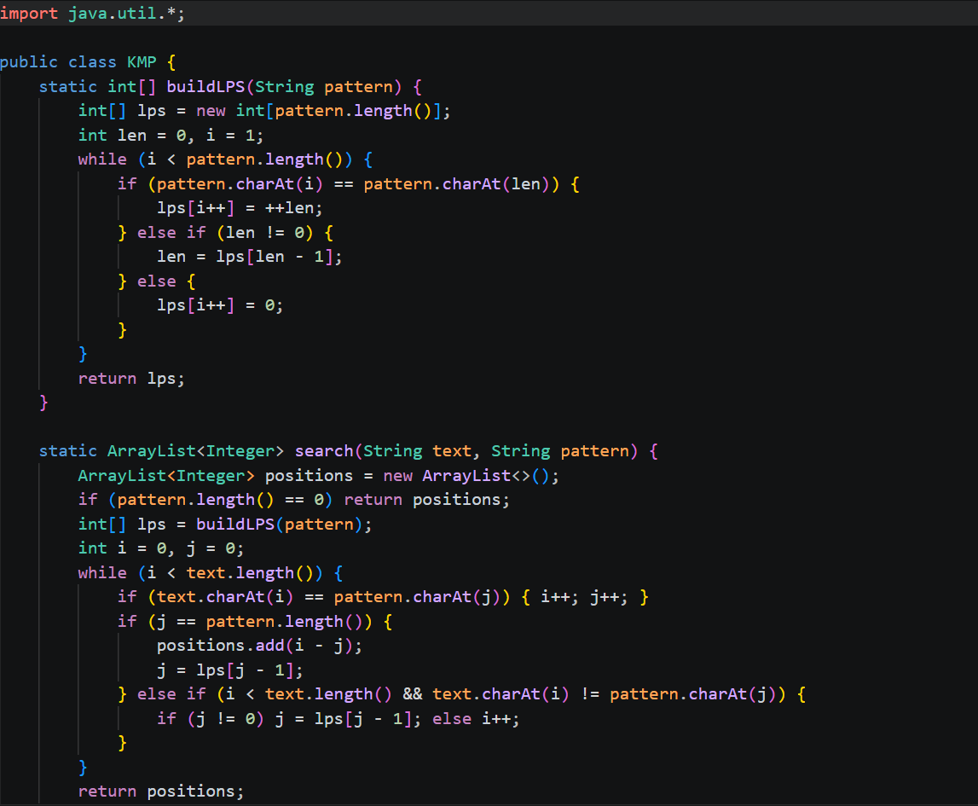
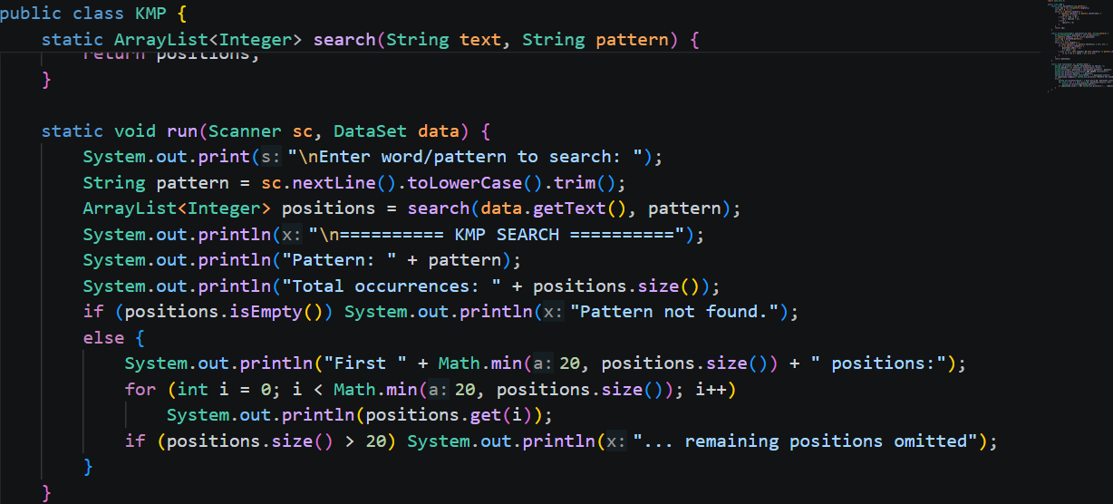
6.4 Edit Distance Module
The Edit Distance algorithm is implemented using dynamic programming. The program first obtains the words from the selected dataset and creates a set of unique words.
For every unique word, the algorithm calculates the minimum number of insertions, deletions, and substitutions required to transform the entered word into that word. The word having the minimum edit distance is selected as the closest spelling match.
The output displays the input word, closest word, and calculated edit distance.
Code file: EditDistance.java
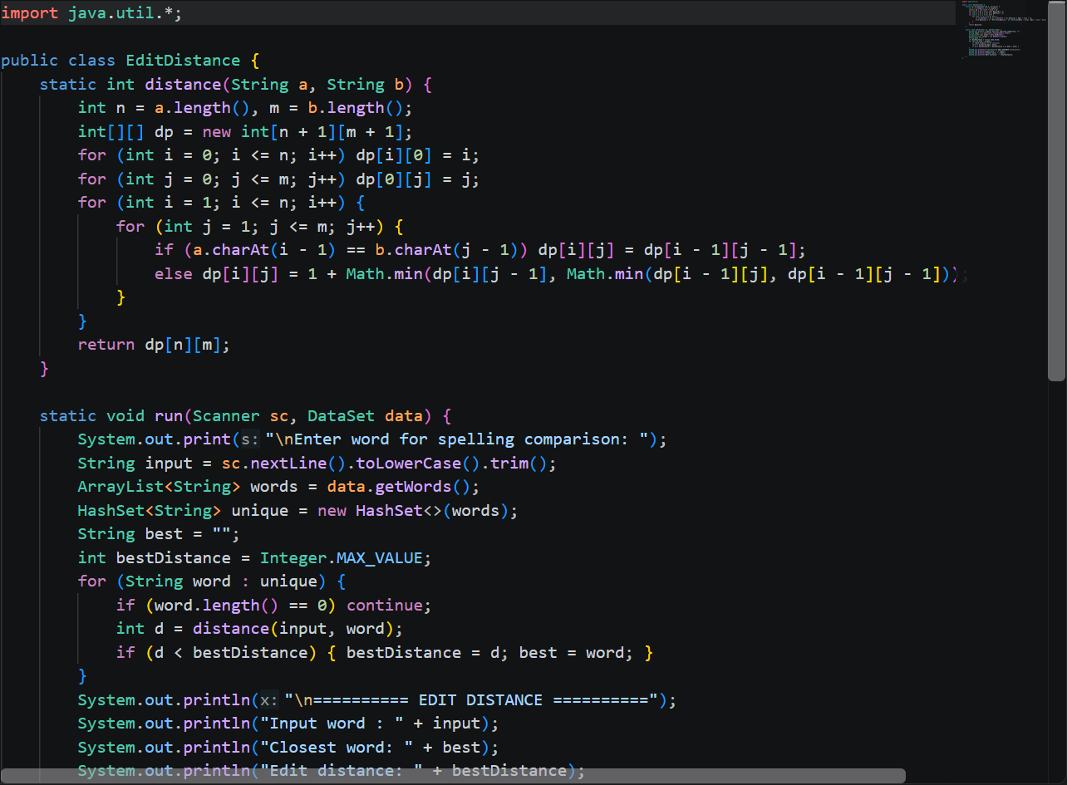

6.5 Aho-Corasick Multiple Keyword Searching Module
The Aho-Corasick algorithm is implemented using a trie-based structure. Each keyword is inserted into the trie and failure links are constructed using a queue.
After constructing the automaton, the selected dataset is processed once. Whenever a keyword is found, its occurrence count is increased. The system finally displays the occurrence count for every entered keyword and the total number of matches.
This approach allows multiple keywords to be searched simultaneously instead of separately processing the complete text for each keyword.
Code file: AhoCorasick.java
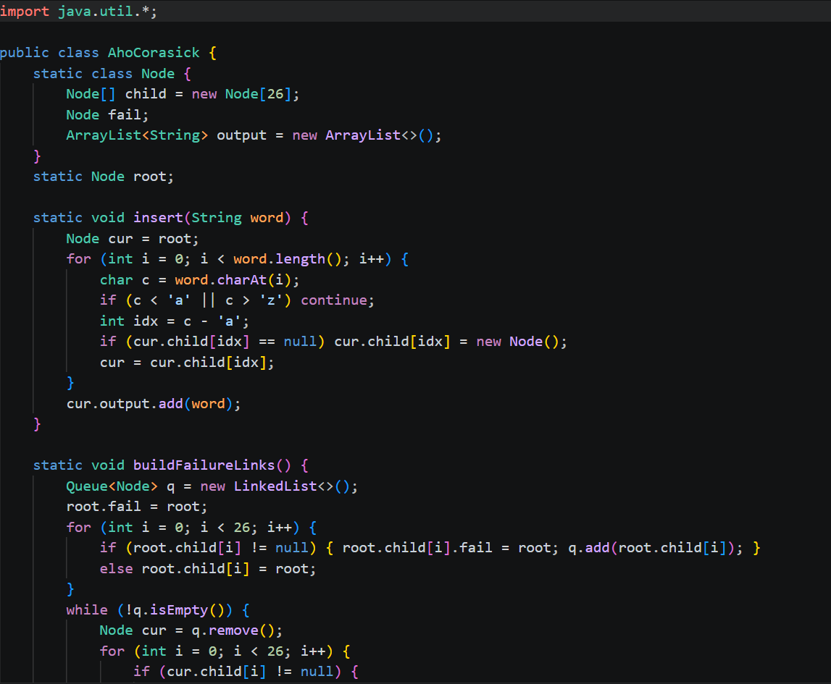
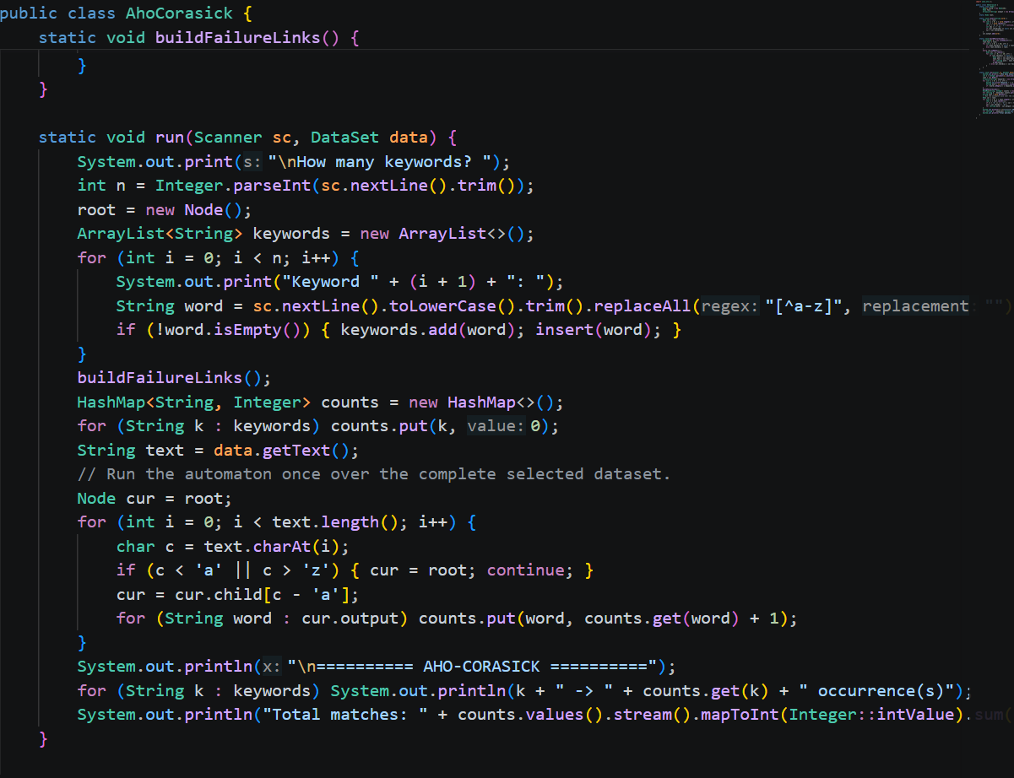
6.6 Suffix Array Module
The Suffix Array module creates an array containing the starting positions of all suffixes of the selected text in sorted order.
To keep the memory and execution requirements practical for the project, the implementation analyzes a maximum of the first 6000 characters of the selected dataset. The suffixes are sorted using Java's sorting functionality and the first 20 suffix indexes are displayed.
The output also displays the number of characters indexed and the total number of suffixes.
Code file: SuffixArray.java
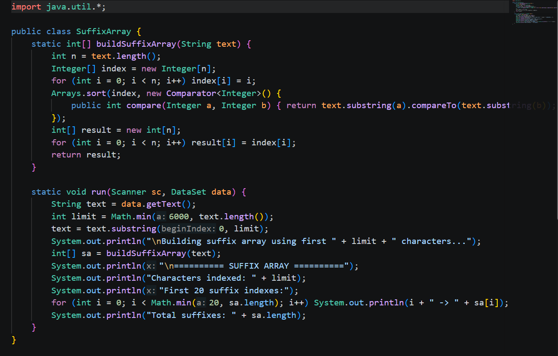

6.7 LCP Array Module
The LCP Array module works with the suffixes generated from the selected text. Similar to the Suffix Array implementation, it analyzes a maximum of the first 6000 characters.
The program compares adjacent suffixes and calculates the number of characters they have in common from the beginning. This value represents the Longest Common Prefix between the two suffixes.
The system displays the first 20 LCP values together with their corresponding suffix indexes.
Code file: LCPArray.java
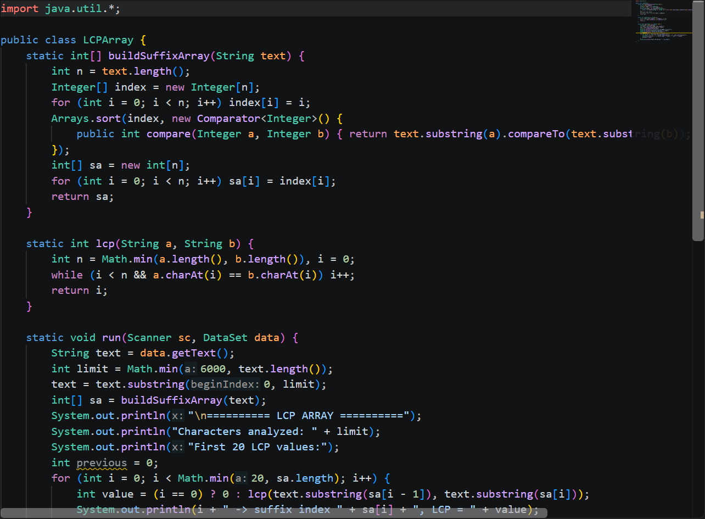

- RESULTS & DISCUSSION

The developed system successfully provides a menu-driven environment for performing different text-searching and analysis operations. The application allows both the predefined dataset and a user-provided .txt dataset to be selected.
  - Dataset Selection
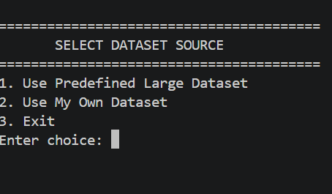
The application first asks the user to select the dataset source. The user can choose the predefined large dataset, provide a custom .txt dataset path, or exit the application.

  - Dataset Information
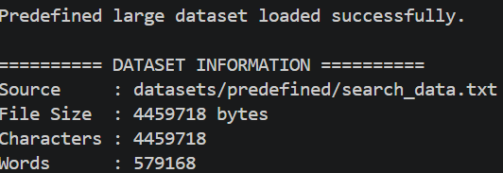
The predefined dataset supplied with the project contains 4,459,718 characters and 25,000 newline-separated records. The program displays the source, file size, character count, and calculated word count when the dataset is loaded.

7.3 KMP Search Result
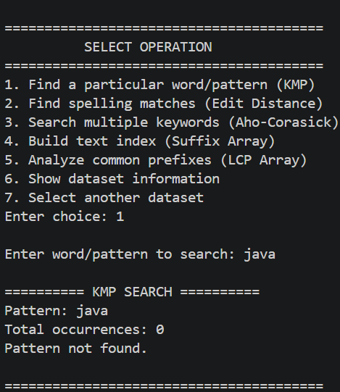
The KMP module accepts a word or pattern from the user and searches the complete selected text. The output displays the total number of occurrences and the first 20 positions where the pattern occurs.

  - Edit Distance Result
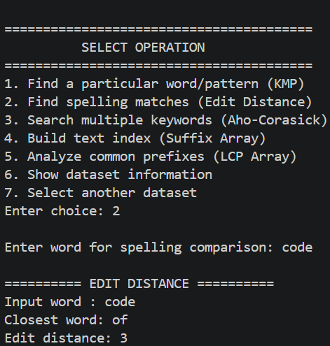
The Edit Distance module compares the entered word with unique words extracted from the dataset. It displays the closest matching word and the minimum edit distance obtained.
7.5 Aho-Corasick Result
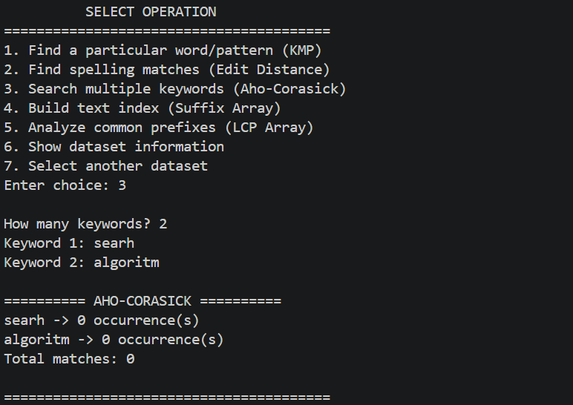
The Aho-Corasick module accepts multiple keywords and searches them simultaneously through the complete selected dataset. The output displays the occurrence count for each keyword and the total number of matches.

7.6 Suffix Array Result
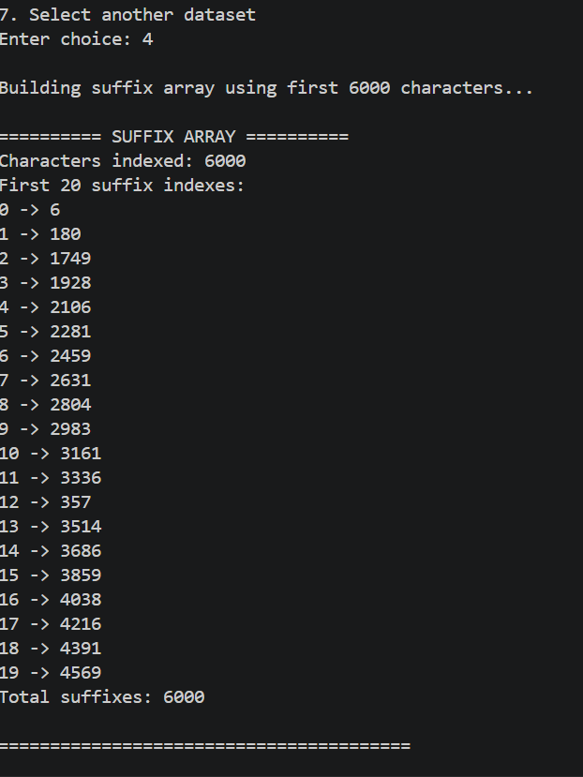
The Suffix Array module analyzes up to the first 6000 characters of the selected dataset. It constructs the suffix array and displays the first 20 suffix indexes along with the total number of suffixes.

7.7 LCP Array Result
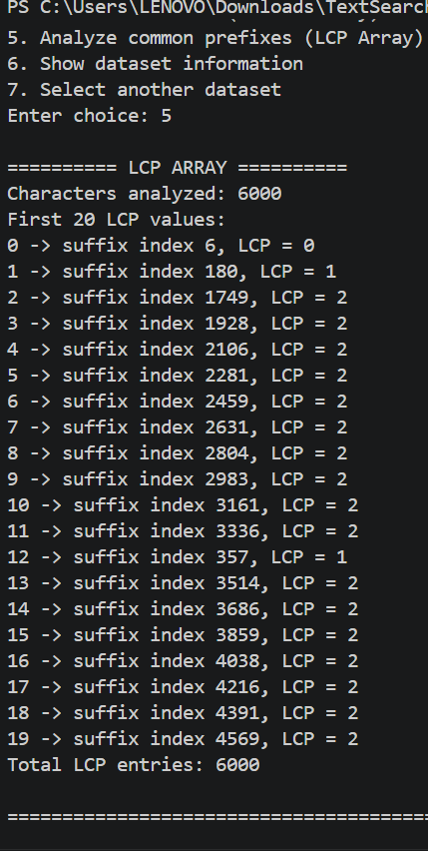
The LCP Array module analyzes the same maximum 6000-character portion of the selected dataset. It calculates the longest common prefix between adjacent suffixes and displays the first 20 LCP values.

7.8 Discussion
The results demonstrate that different algorithms can be used for different text-processing requirements. KMP is suitable for searching one pattern, Edit Distance is useful for spelling comparison, and Aho-Corasick is suitable when several keywords need to be searched together. Suffix Array provides a method for text indexing, while the LCP Array provides information about similarities between adjacent sorted suffixes.
The system therefore demonstrates the practical use of multiple data structures and algorithms within a single application. The use of a common dataset also makes it possible to apply different techniques to the same text and observe their respective outputs.

- CONCLUSION & FUTURE SCOPE

Conclusion
The Text Search and Analysis System successfully demonstrates the practical implementation of different data structures and algorithms for text searching and analysis. The project provides a single Java-based application through which users can select a dataset and perform different text-processing operations.
The implementation includes the Knuth-Morris-Pratt algorithm for pattern searching, Edit Distance for spelling comparison, Aho-Corasick for multiple keyword searching, Suffix Array for text indexing, and LCP Array for common-prefix analysis.
The project demonstrates that different text-processing problems require different algorithmic approaches. It also provides practical understanding of pattern matching, dynamic programming, trie-based searching, suffix-based indexing, and prefix analysis.

Future Scope
The project can be enhanced in several ways in the future.
- A graphical user interface can be developed to make the application easier to use.
- Search results can be displayed with highlighted matching text.
- Execution time and memory usage of each algorithm can be measured and compared.
- Additional pattern-matching algorithms such as Rabin-Karp and Boyer-Moore can be implemented.
- More efficient Suffix Array construction techniques can be incorporated.
- The system can be extended to support additional file formats such as PDF and DOCX.
- An inverted index can be implemented for faster document retrieval.
- A ranking mechanism can be added to order search results according to relevance.
- The application can be converted into a web-based text search system.
- Natural-language queries and advanced search functionality can be added in future versions.

- REFERENCES

  - Oracle, Java Documentation.
https://docs.oracle.com/en/java/
  - Knuth-Morris-Pratt Algorithm, Wikipedia.
https://en.wikipedia.org/wiki/Knuth%E2%80%93Morris%E2%80%93Pratt_algorithm
  - Aho-Corasick Algorithm, Wikipedia.
https://en.wikipedia.org/wiki/Aho%E2%80%93Corasick_algorithm
  - Edit Distance, Wikipedia.
https://en.wikipedia.org/wiki/Edit_distance
  - Suffix Array, Wikipedia.
https://en.wikipedia.org/wiki/Suffix_array
  - Longest Common Prefix, CP-Algorithms.
https://cp-algorithms.com/string/suffix-array.html
  - String Searching Algorithms, GeeksforGeeks.
https://www.geeksforgeeks.org/string-data-structure/
  - Dynamic Programming, GeeksforGeeks.
https://www.geeksforgeeks.org/dynamic-programming/
  - Java Collections Framework, Oracle Documentation.
https://docs.oracle.com/javase/8/docs/technotes/guides/collections/overview.html
  - String Algorithms, CP-Algorithms.
https://cp-algorithms.com/string/

